Problem 1: <https://www.circuitlab.com/circuit/uc726aq5p57d/circuits-hw-part-1/>

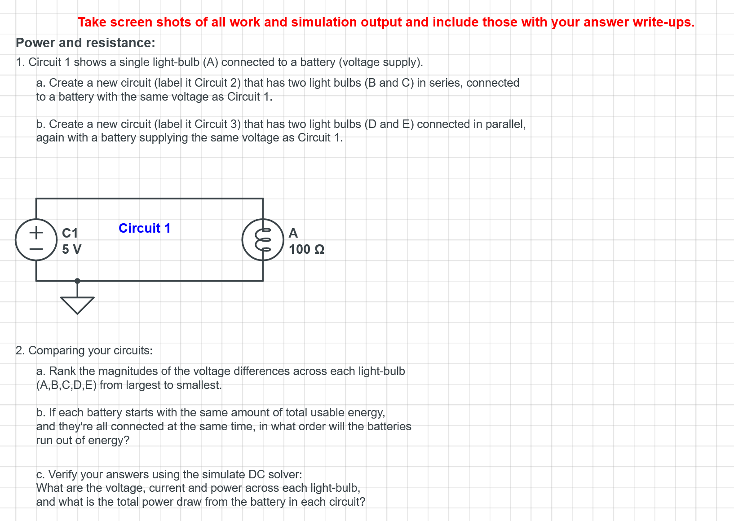

Problem 2: <https://www.circuitlab.com/circuit/b5679prh87s3/circuits-hw-part-2/>

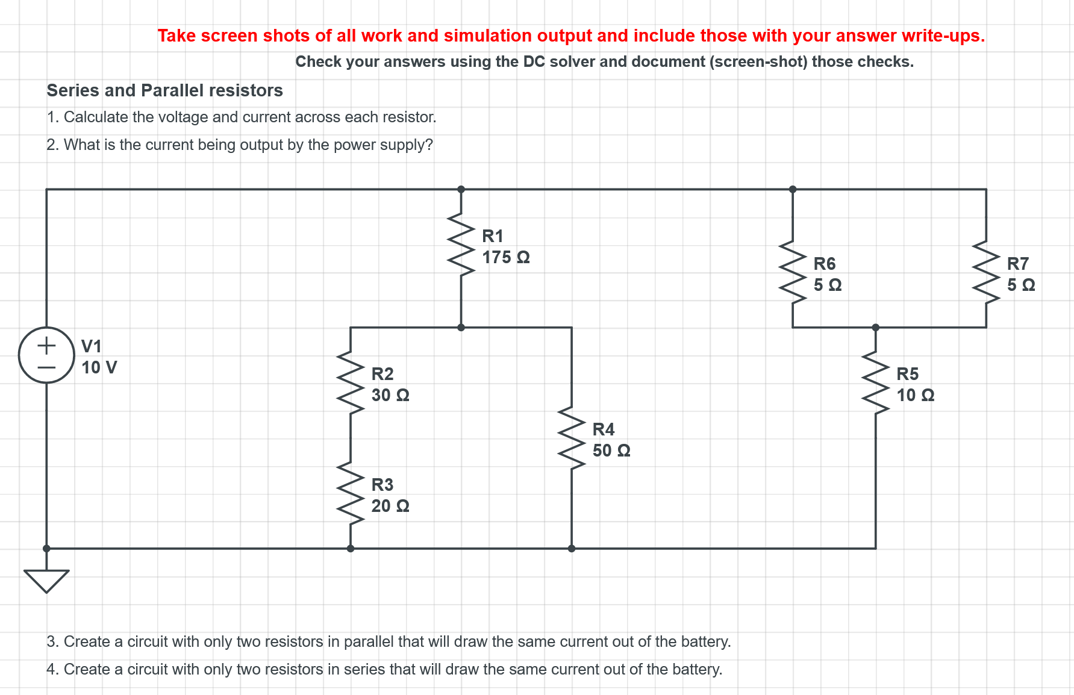

Problem 3: <https://www.circuitlab.com/circuit/w24j2fdnucww/circuits-hw-part-3/>



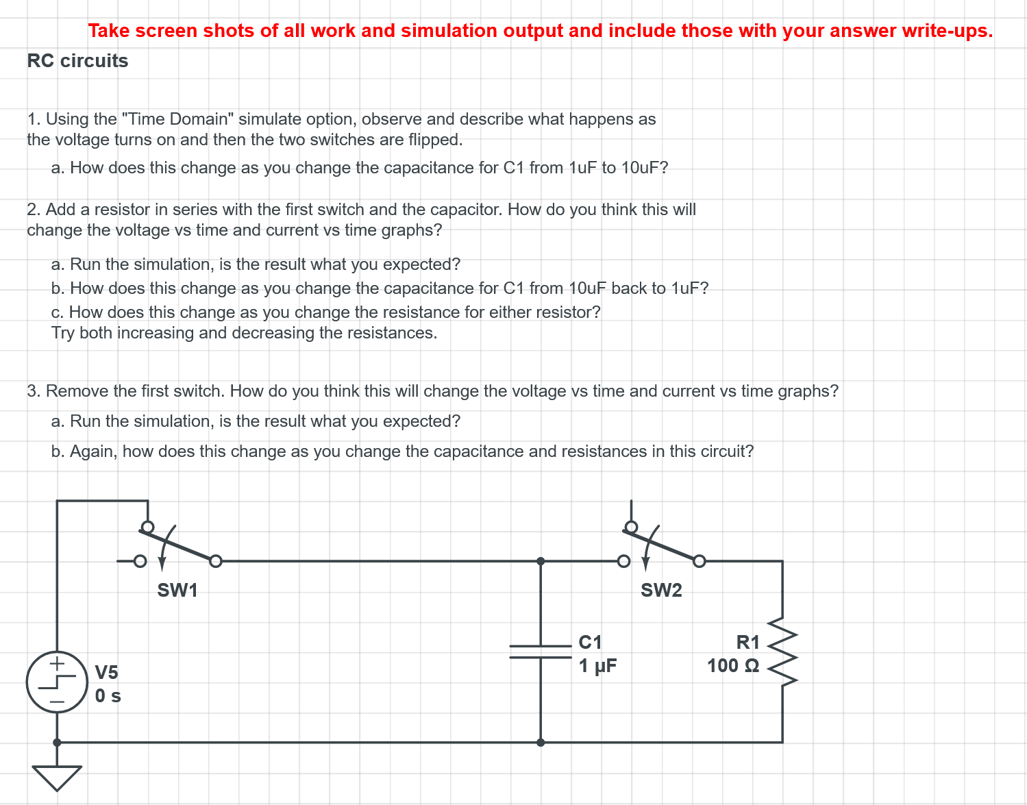

Problem 4: <https://www.circuitlab.com/circuit/k76996c3u75a/circuits-hw-part-4/>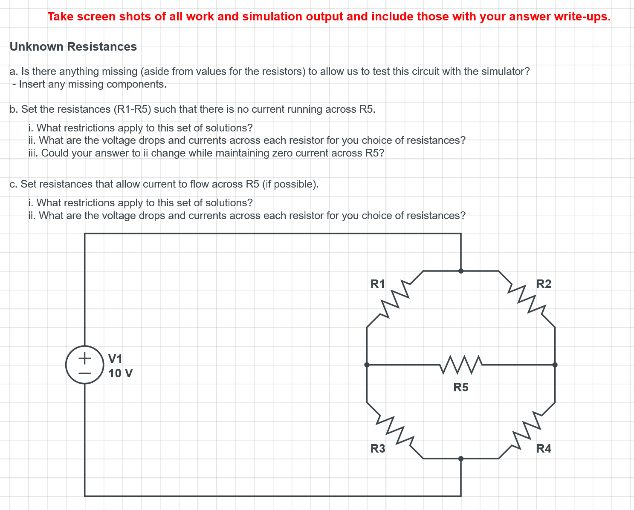

Problem 5: <https://www.circuitlab.com/circuit/346np3j7f2ux/circuits-hw-part-5/>

